**Uptiq AI Workbench Output Document**

**Overview:**

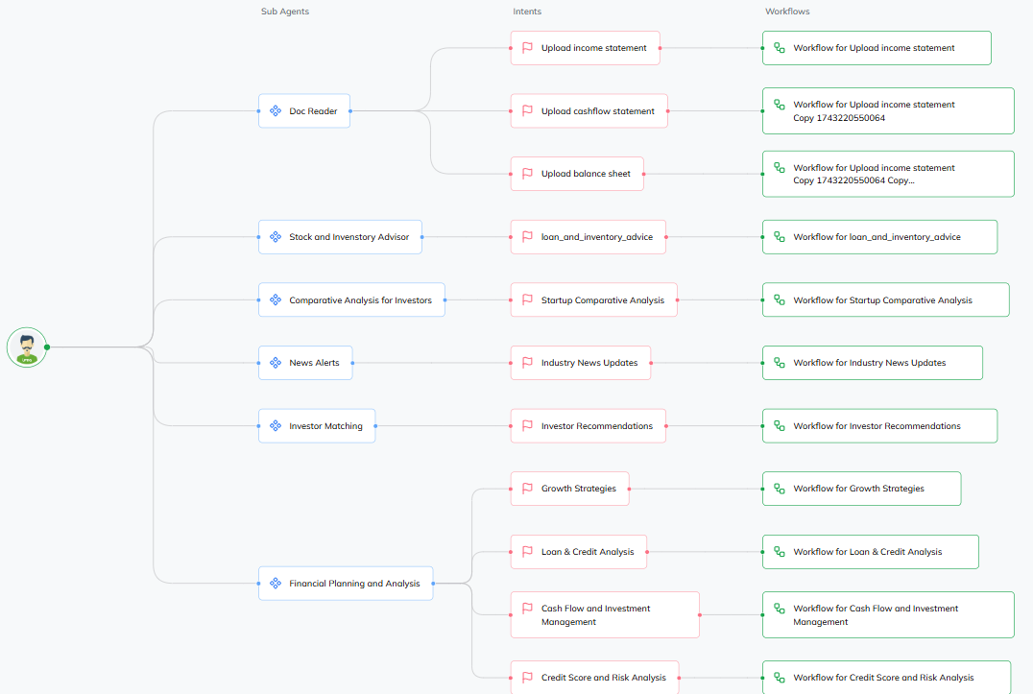

1. **Document Reader**

a.Income Sheet Reader:

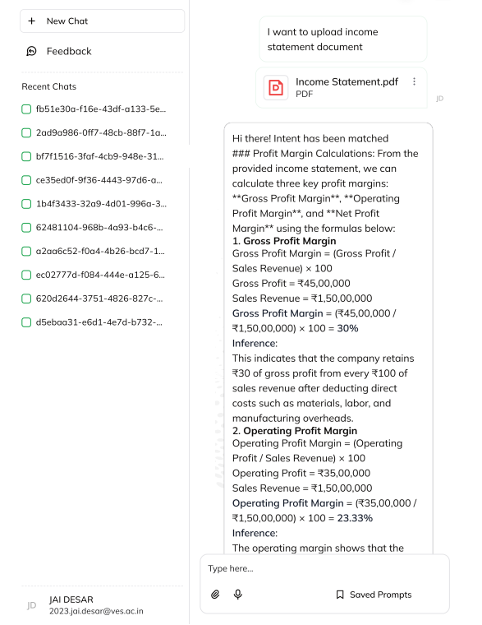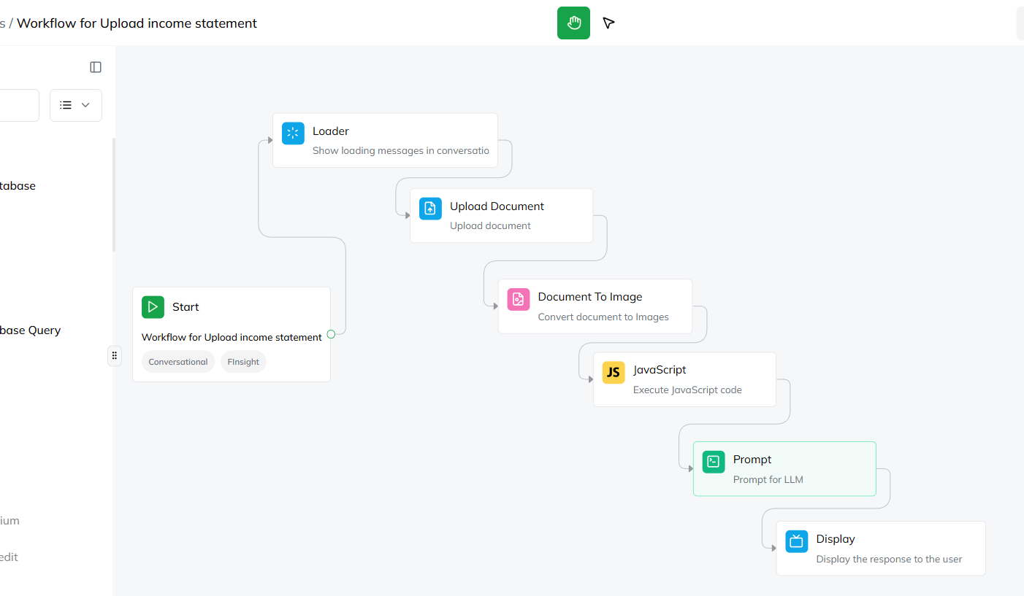

b.Cash Flow Statement Reader:

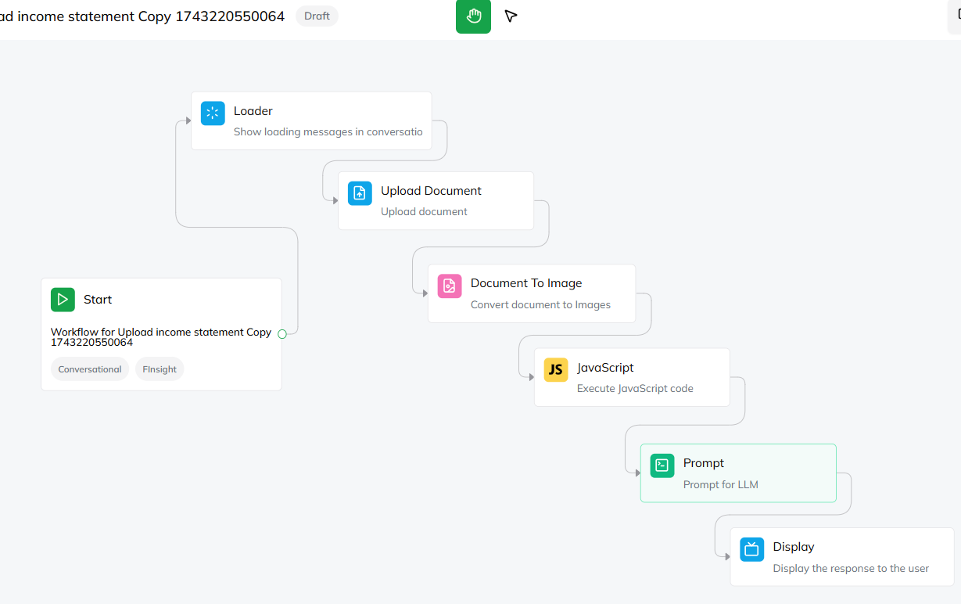

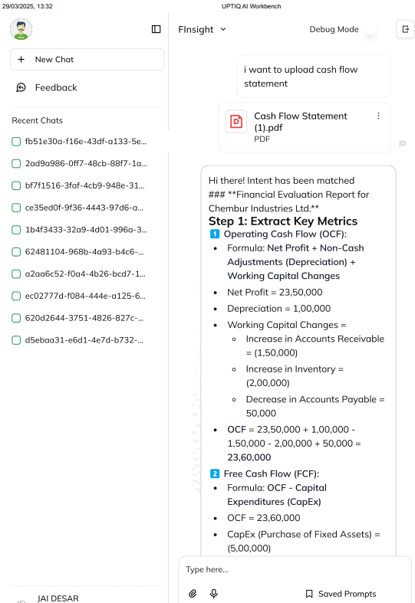

c.Balance Sheet Reader: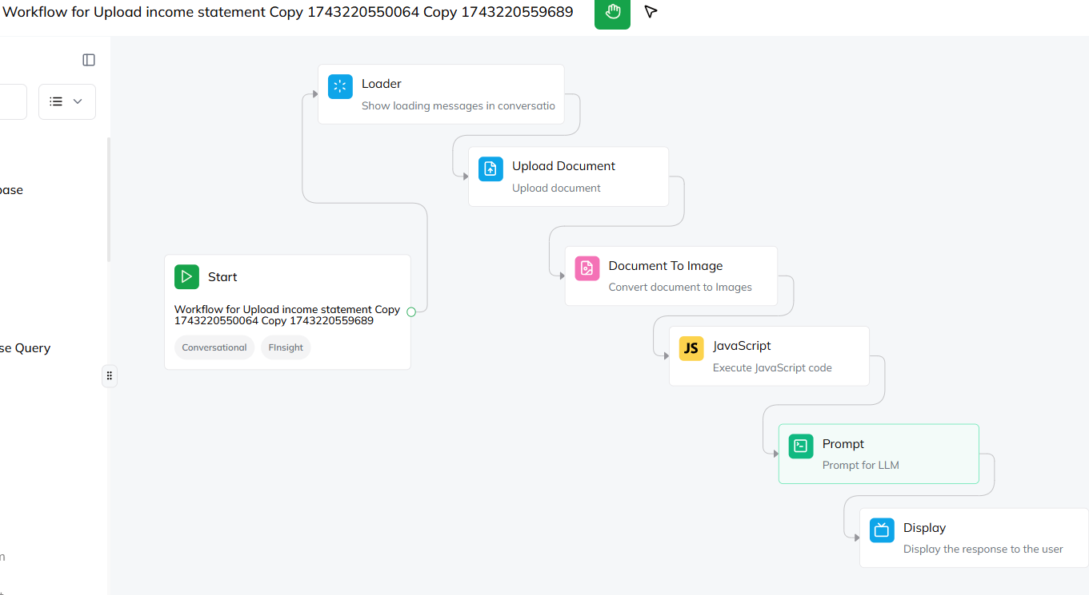

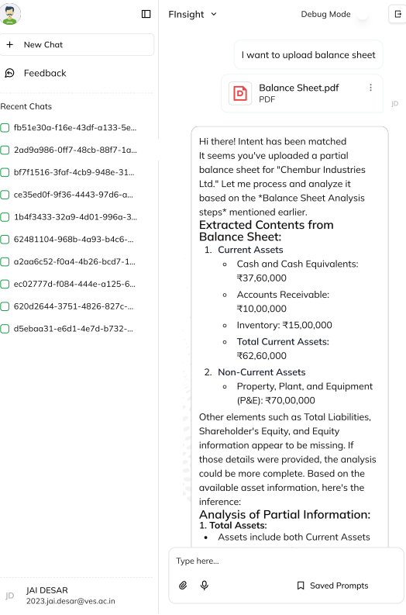

**2. Stock and Inventory Advisor**

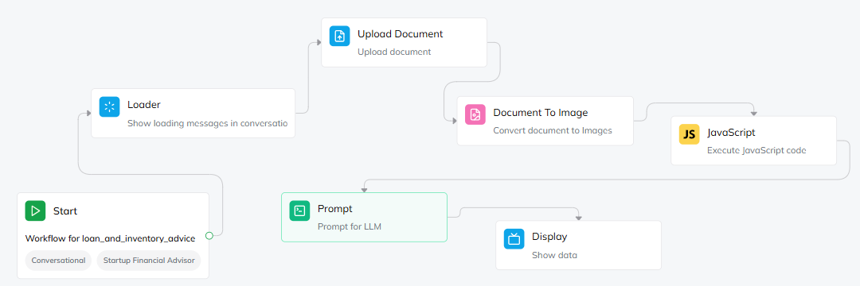

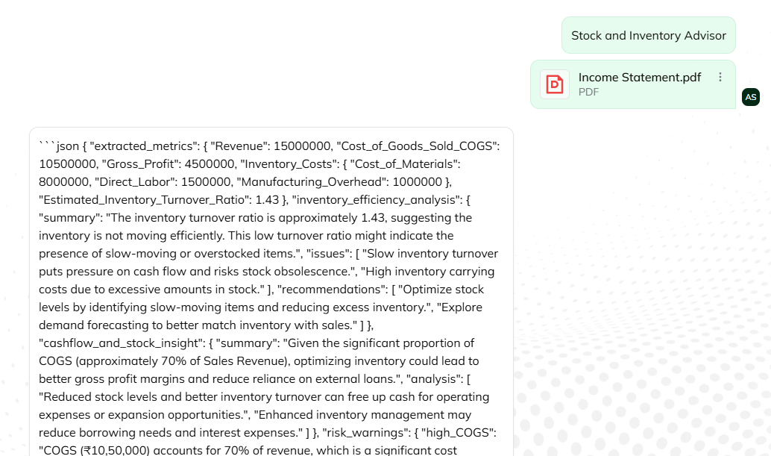

**3. News Alert (moneycontrol.com)**

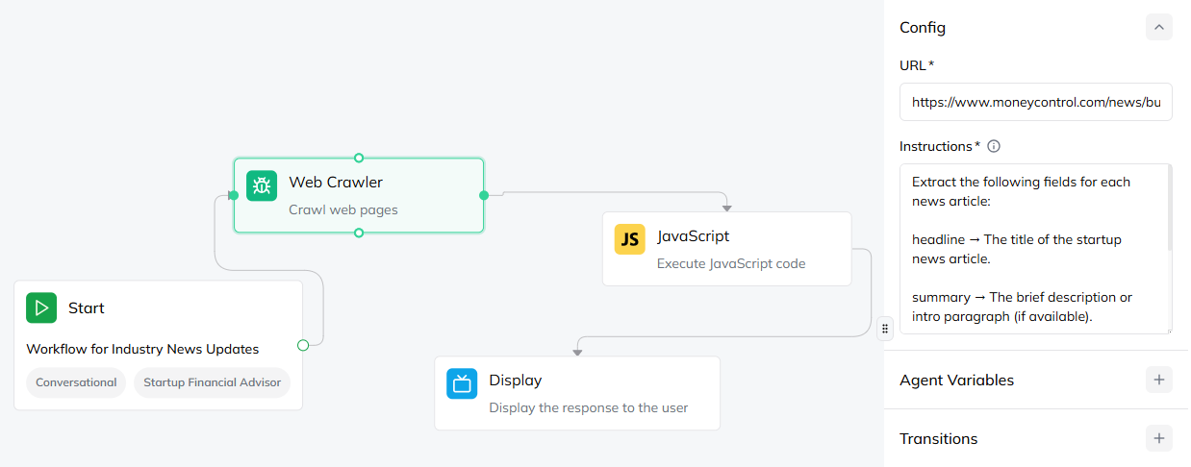

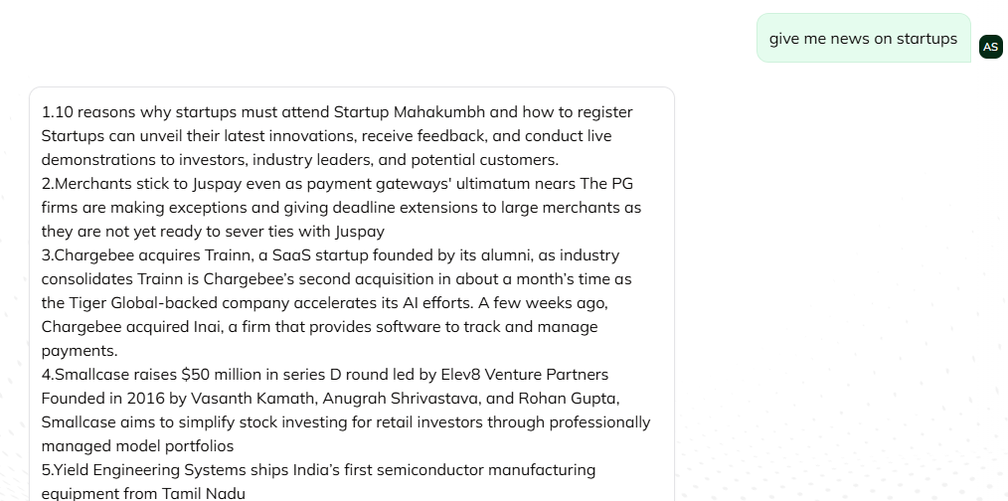

**4. Loan and Credit Analysis (bestfd.in)**

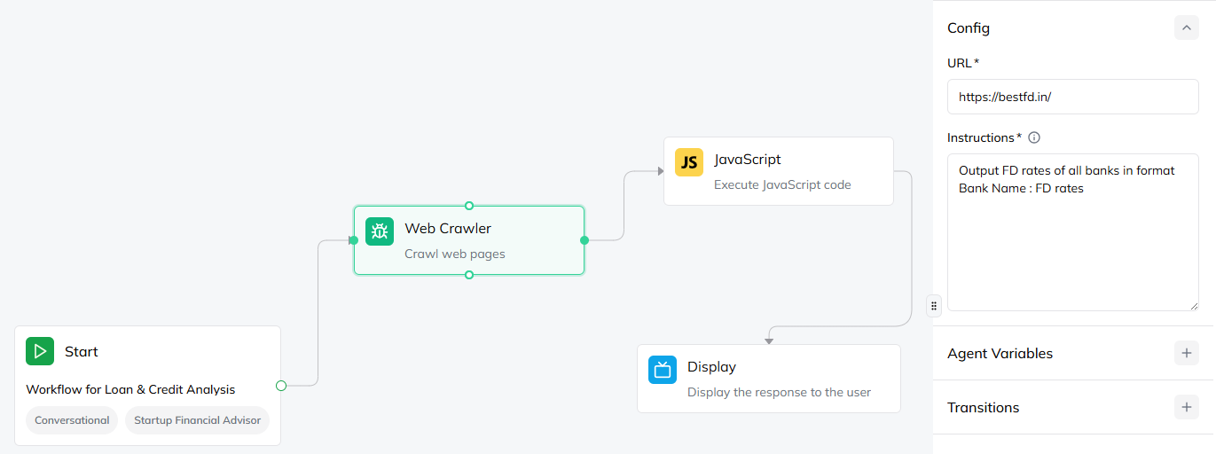

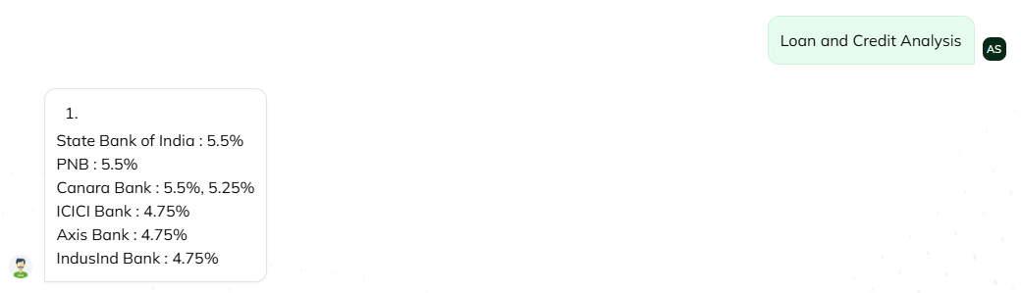

**5. Cash Flow and Investment Management**

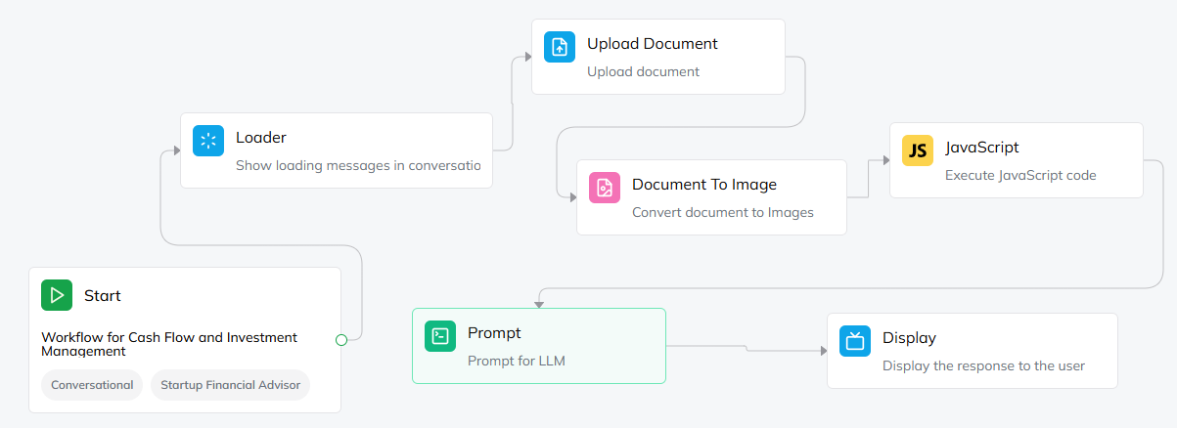

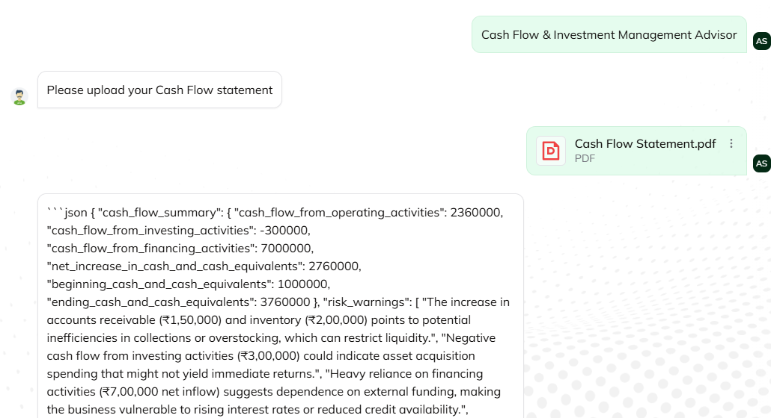

**Challenges we faced** during creation of agents in UPTIQ AI Document Link : [SYRUS UPTIQ AI PROBLEMS](https://docs.google.com/document/d/1Z3XwK1-BHcxPAWj-T-CdJDOwcl7FLI875ZaB0G_BQiQ/edit?usp=sharing)

(also contains reason as to why the output looks **cryptic for subagents** that output in json format)